Click here to view this message in your browser.



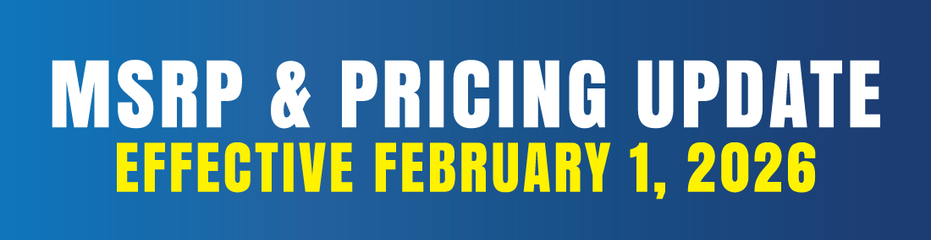

Dear Scotsman Partners,

Scotsman appreciates your ongoing partnership and commitment to delivering exceptional products and service to your customers. As part of our continued efforts to support your business and maintain a strong brand presence, we are implementing updates to our MSRP program. Updated policy and pricing information is enclosed.

MSRP Program Updates – Effective February 1, 2026

﻿Exclusion of Non-Serialized Accessories
- To provide additional dealer pricing and promotional flexibility, the following non-serialized accessories will be excluded from the MSRP program: Water Filters, Kits, KVS, Line Sets, XR-30
- Updated price list below reflects which models are exempt from MSRP.
*Note that the following serialized accessories will remain subject to MSRP: Storage Bins, Hotel/Ice Only Dispensers, Machine Stands, Remote Condensers

Discontinued Model Exemptions
- All previous models that were transitioned in 2025 have been discontinued and have become MSRP-exempt effective January 1, 2026.
*Note: Remote models and R449A models planned to transition in 2026 will remain subject to MSRP until further notice.

2025 MSRP Recap

As a reference, below is a recap of last year’s MSRP policy updates, which became effective March 15, 2025.

MSRP Multiplier Update
- The MSRP multiplier was updated to .41 x current list price (up from .40).

Prohibition of Direct Resale to 1P (First-Party) Platforms
- Direct resale to 1P/first-party platforms was prohibited to ensure dealer partners are not disadvantaged by “Sold by Amazon” listings.
- Dealers may continue selling on third-party marketplaces, provided they adhere to MSRP pricing.

Exemption for Contract and Bid Submissions
- Contract and bid submissions were made exempt to allow dealers to remain competitive on bid projects and design/build work.
﻿
We value your cooperation and are committed to supporting your success. If you have any questions or require further clarification, please do not hesitate to reach out to your account manager.

Thank you,
﻿
Jeff Biel
VP of Marketing and Customer Experience

Scotsman 2026 Commercial MSRP Program

Scotsman Commercial MSRP Price List (Feb 2026)

