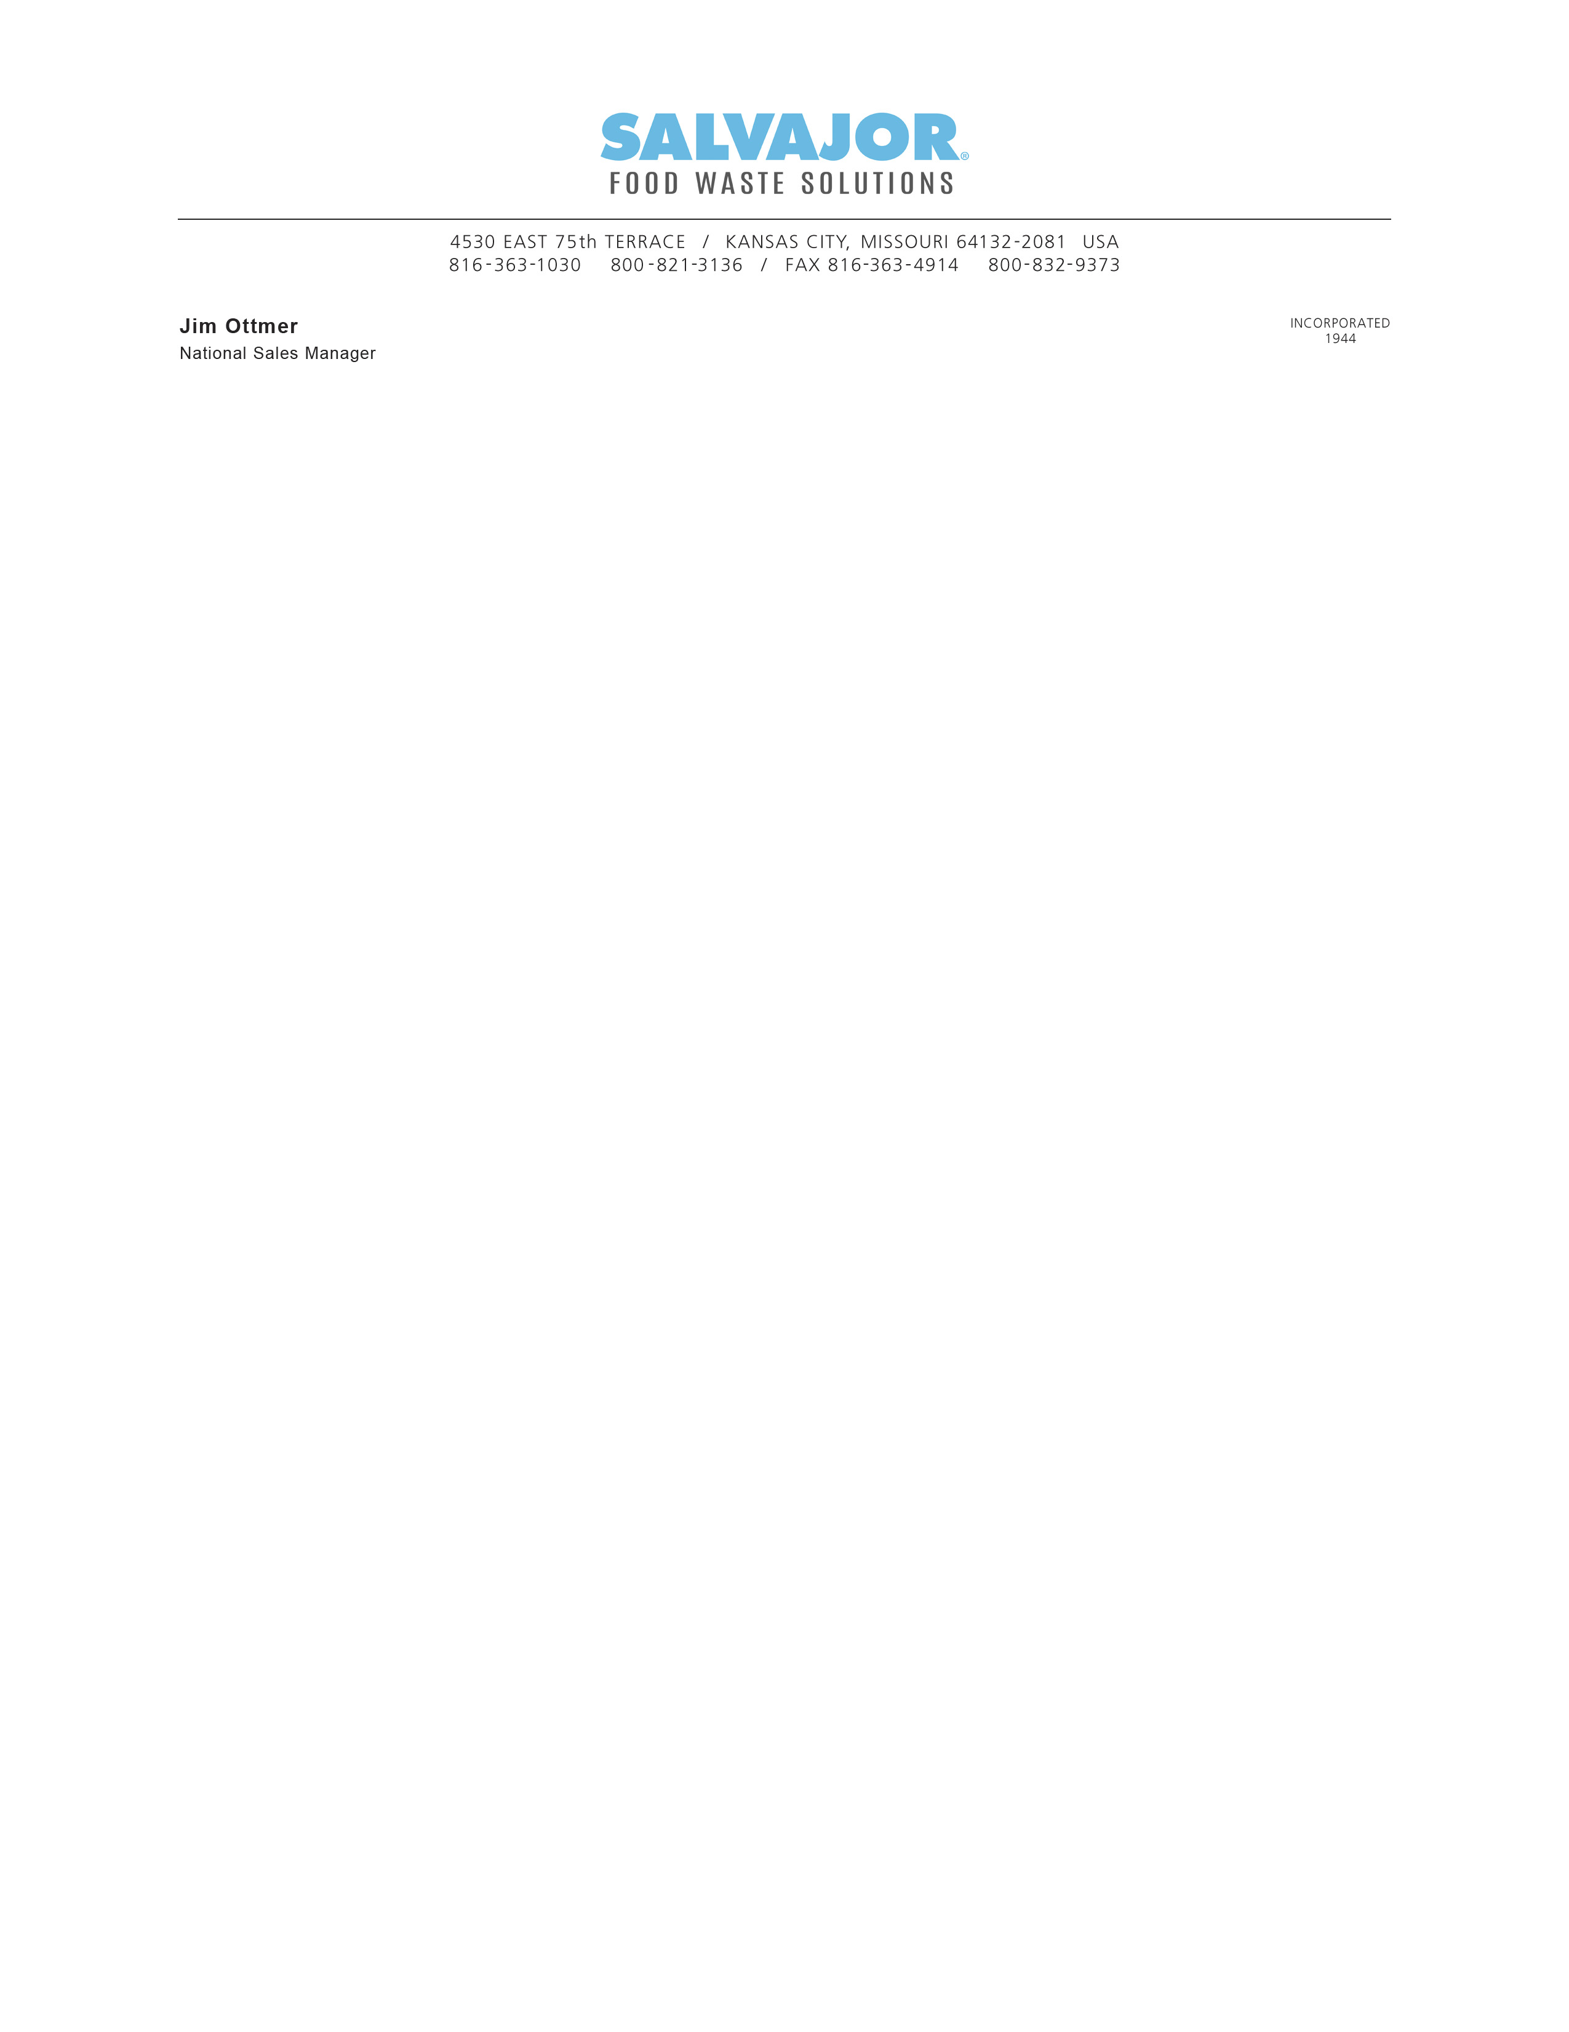
12/4/2024

To: NAFED

Dear Valued Partner,

Salvajor thanks you for being such a loyal and consistent customer. Your satisfaction is very important to us, and we hope Salvajor has been successful in providing you with excellent customer service and products.

Due to the current economy, we will be raising our prices on all products. This increase will be 5% on all products and will take effect beginning January 1, 2025.

This price increase is necessary to continue providing you with the quality you've come to expect. Please don't hesitate to contact me immediately if you have any questions or concerns.

Please consider this your 30-day notice and let your members know that new pricing will go into effect 1/3/25.

Thank you,

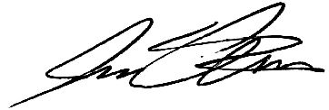
Jim Ottmer, CFSP
National Sales Manager




