

Globe & Varimixer Price Increase: Effective
August 1, 2026
The Globe & Varimixer price increase is effective August 1, 2026.
Please find the updated spreadsheets and price books below.
Contact your RSM with any questions.

  
  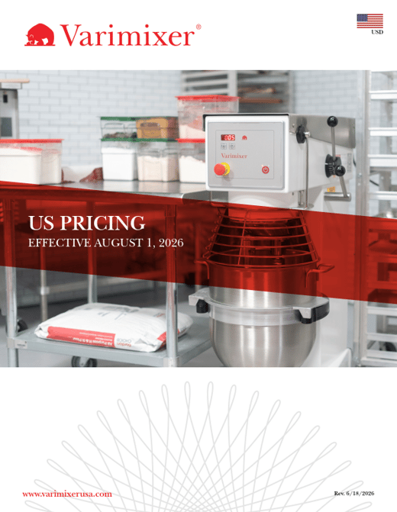

  Globe US Spreadsheet
  Globe GAP+ Price Book
  Varimixer US Spreadsheet
  Varimixer US Price Book

Prices are subject to change without notice. For the most current pricing information, please refer to Setvi.

  
  
  
  

Globe Food Equipment, 2153 Dryden Road, Dayton, OH 45439, 800-347-5423
Unsubscribe Manage preferences

